Policy Name | Behaviour Policy
Date of Issue | September 2023
Author | L Bridge
Reviewed by | L Bridge
Date of next review | September 2025

Scope of the Behaviour Policy
This policy applies to Landau Forte Academy Greenacres.

Purpose of the policy
We believe that we promote good behaviour by creating a happy caring environment where everyone feels valued and respected.
Aims
- To create an ethos that makes everyone in the Academy feel valued and respected.
- To promote good behaviour by forging sound working relationships with everyone involved with the Academy.
- To provide good role models to demonstrate good behaviour.
- To develop respect for their own and other people's property.
- To develop a feeling of responsibility and care for their school and for their environment.

Policy Detail

Positive Rewards Systems
A variety of positive reward systems are in place, these include:
- Regular praise and encouragement from all staff.
- Golden time/privilege time in minutes for the whole class. Minutes cannot be taken away but individual pupils can miss time.
- Classroom rewards e.g. stamps, stickers, certificates, house points, etc.
- Principal's stickers and certificates.
- Class dojo points.
- Certificates/soft toys to hold for good sitting/listening.
- Certificates in celebration assembly and their names entered into the Good book.
- Names written under the 'Happy Face'.
Strategies for dealing with Inappropriate Behaviour:
Sanctions should be applied in a manner that maintains the child's self-respect and whole group sanctions should be avoided.
1st Level - Verbal warning
A visual aid for the children is used, this may include a sunshine and cloud or happy and unhappy faces. Sanctions board.
2nd level - Isolation in class
Teachers will normally deal with incidents that arise at the time in a manner that is appropriate to the child e.g. sitting on their own away from the rest of the class.
3rd Level - Formal
Time out/withdrawal of privileges. The teacher will record incident in a behaviour book.
Withdrawal from the class for a short period (must be supervised e.g. another class).
Repetitive behavior concerns will be discussed with parents.

4th Level - Referral
Following parental discussion there will be an internal exclusion with the Principal. On the rare occasion that the situation does not improve the Principal will in consultation with the class teacher and, wherever possible, parents decide on appropriate action to be taken: E.g. Lunchtime privileges may be withdrawn or child being placed on report.

CODE OF CONDUCT
Within the school children will be offered the opportunity to develop self-discipline, to have regard for other children and adults and to develop respect for their environment.
Specifically this will mean:
- Behaving in a quiet and orderly way within the school,
- Respect the property of other people.
- Treating their own belongings with care.
- Treating other children with kindness.
- Behaving in the playground in a safe, sensible and controlled manner.
- Developing strategies for dealing with various forms of conflict.

SCHOOL RULES
Following discussions with staff and pupils four main school rules have been drawn up:
- Always try your best.
- Be kind to everyone.
- Take care of your own and other people's belongings.
- Look after our school

5th Level
The Chair of Governors will be informed if any act beyond Level 4 is required.
If necessary the Landau Forte policy on disciplinary procedures will be initiated and there may be an occasion when exclusion from school is instant

SUPPORT FOR STAFF

It is recognised that dealing with behaviour problems can be very stressful for staff and it is not always easy to ask for help.

We believe that dealing with difficult behaviour is the collective responsibility of all staff in the school, not just the teachers immediately concerned with a child

We believe that staff should work together as a team and share the load. Support is always available from Senior Staff, Vice Principal and Principal.

Year Group Staff are responsible for informing supply teachers of any children who need support. The Principal is responsible for supporting colleagues in developing strategies for behaviour management for individual pupils, with the support of the SENCO.
The Principal/Vice Principal will have day-to-day responsibility for discipline matters. In their absence the responsibility will lie with the senior staff. The Principal will be involved with all serious incidents as well as being available to any member of staff requesting support or advice.

Appendix 1

Playground Organisation
The children follow the same rules as in the classroom with the same parameters of acceptable behaviour.

- Whistle procedure - When the whistle is blown the children stop and wait for the teacher to tell them to line up.
- No- one is allowed in teaching areas without teacher permission. A sticker given to the child indicates this.
- When the grass is dry (at the duty teacher’s discretion) the children will be allowed on the grass and the adventure equipment. (See map below)
- During wet playtimes children must stay in their own areas and behave in a calm controlled manner in line with the classroom/school rules.
- Playground equipment- The children may bring skipping ropes and balls.
- Children should walk on pathways at all times.
- Children are expected to play on their designated playground (see map below).

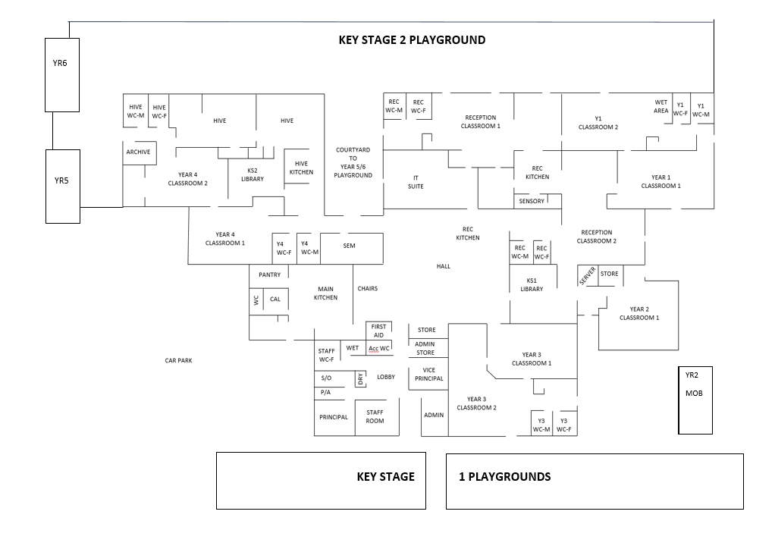

Policy Name | Behaviour Policy
Changes Made | Updates to reflect latest practice
Date Changed | 4th September 2023
Made By | L Bridge
Principal | L Bridge
Chair of Education Advisory Committee | V McBride

